**LAB 5**

1. Add a CHECK constraint to passenger table to provide that passengers must be at least 10 years old.

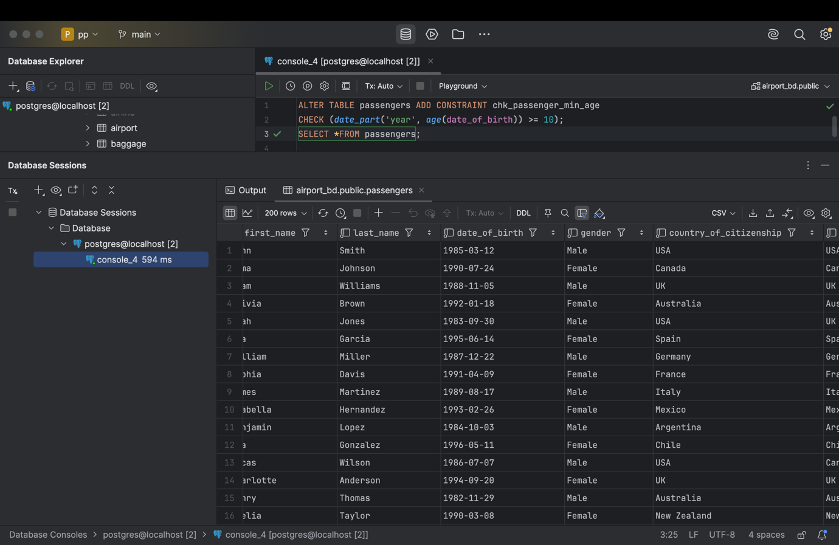

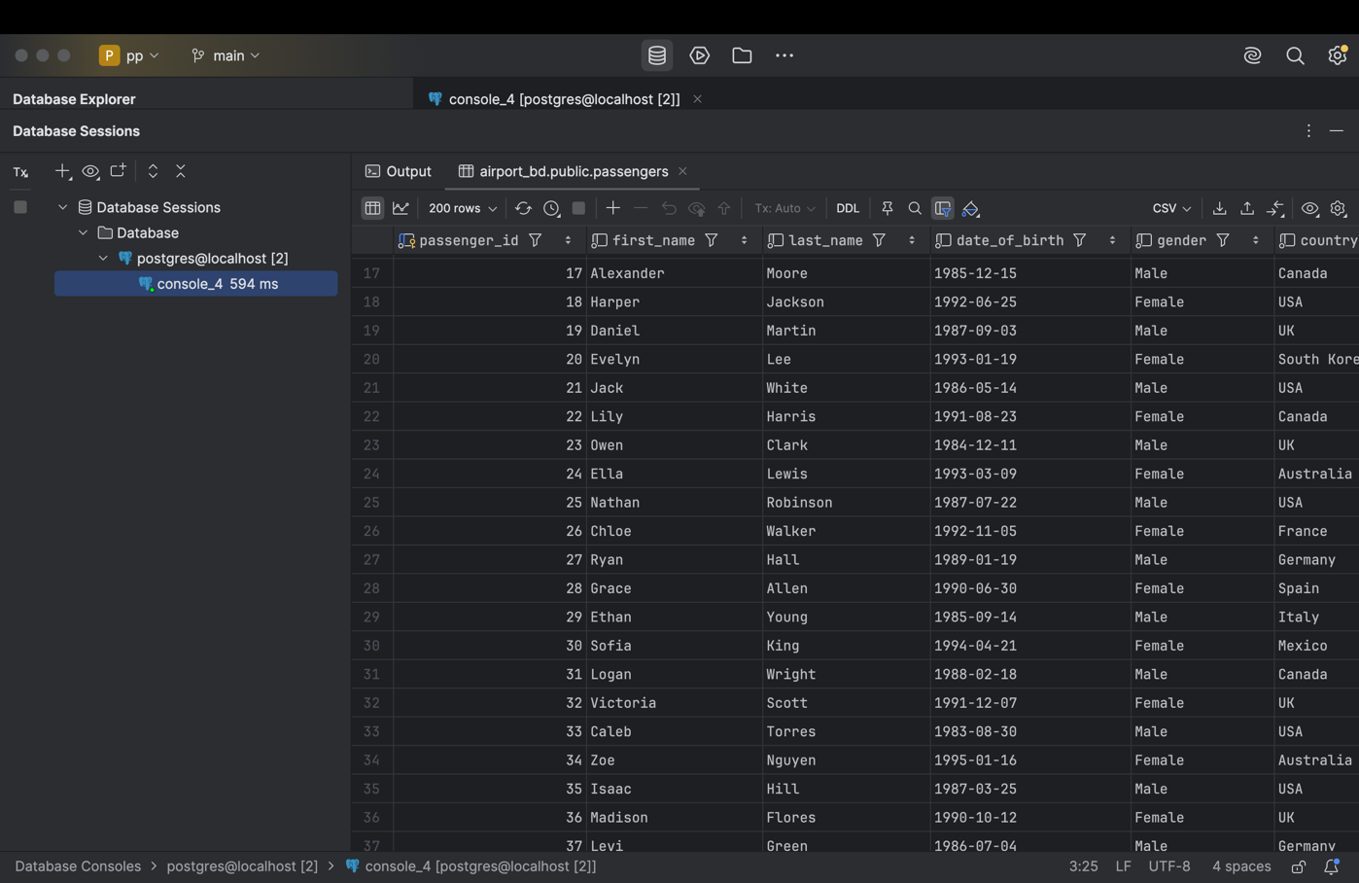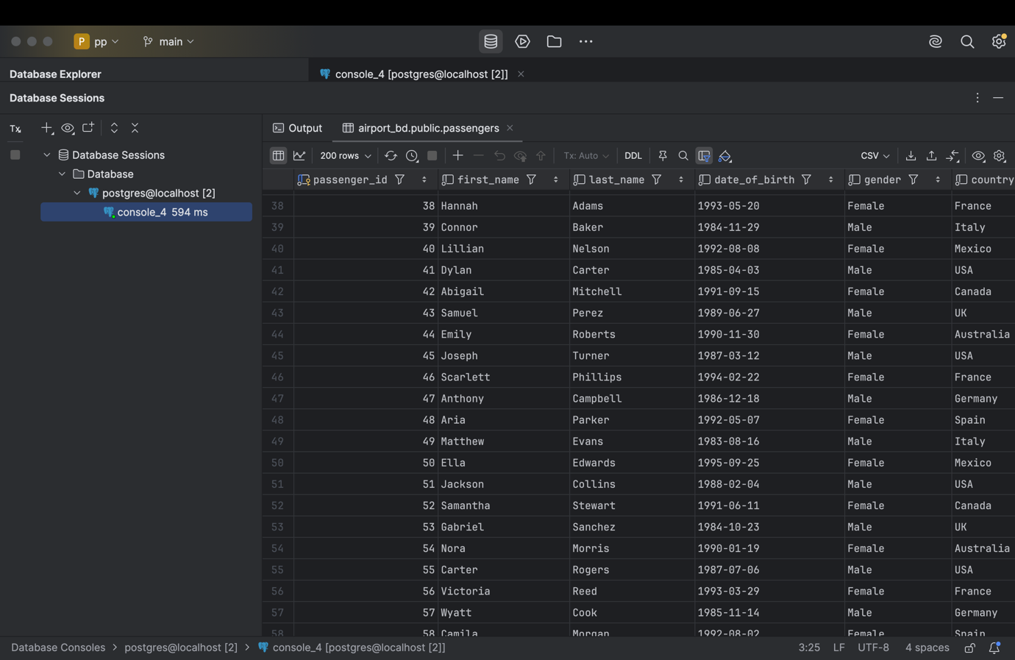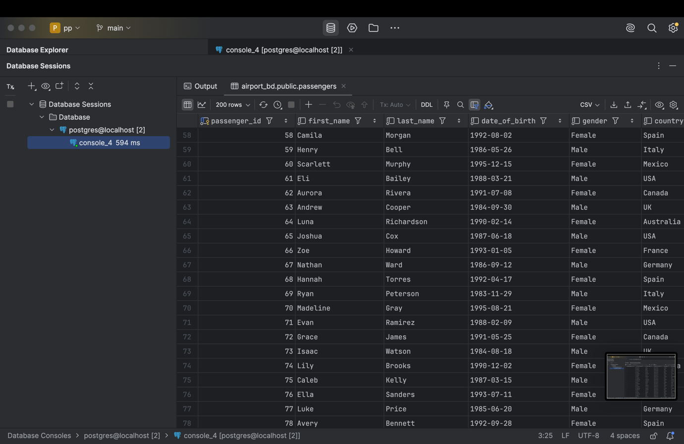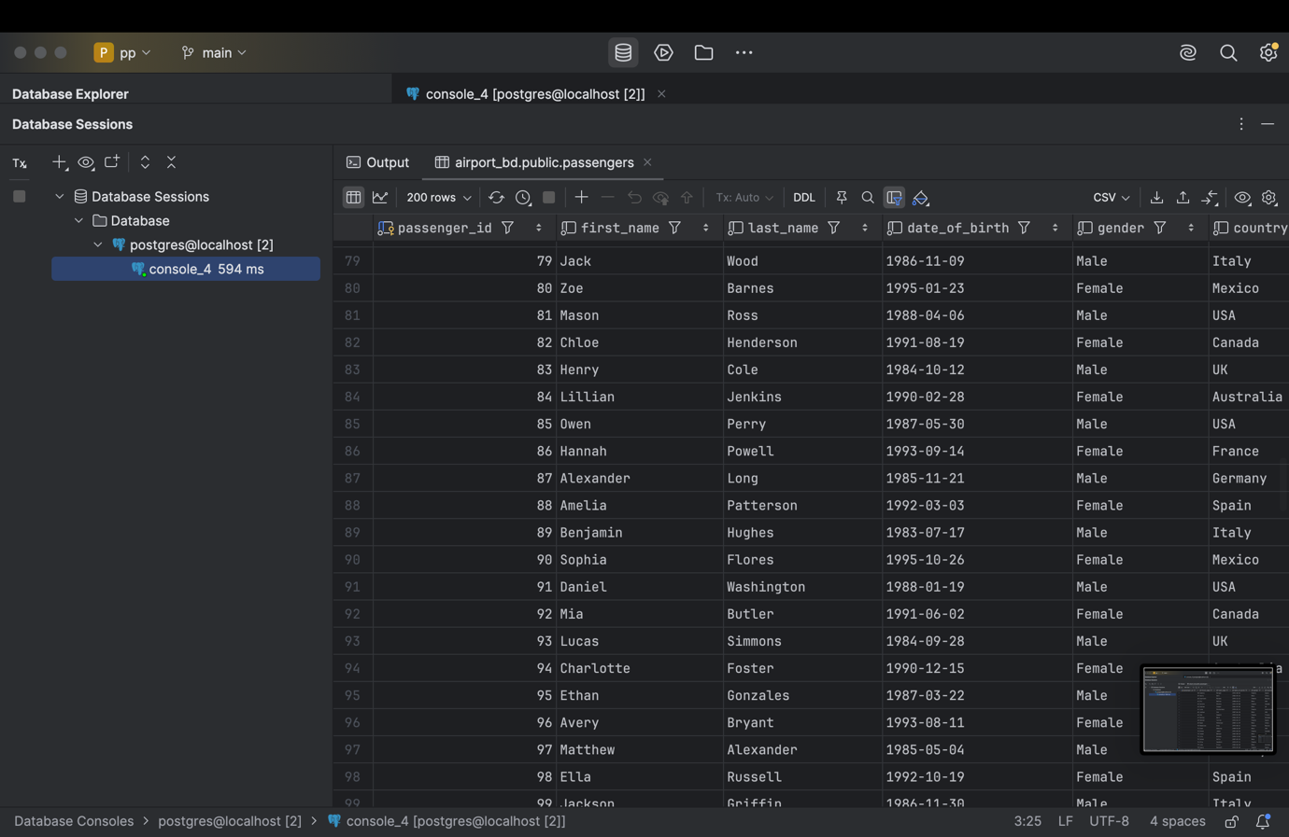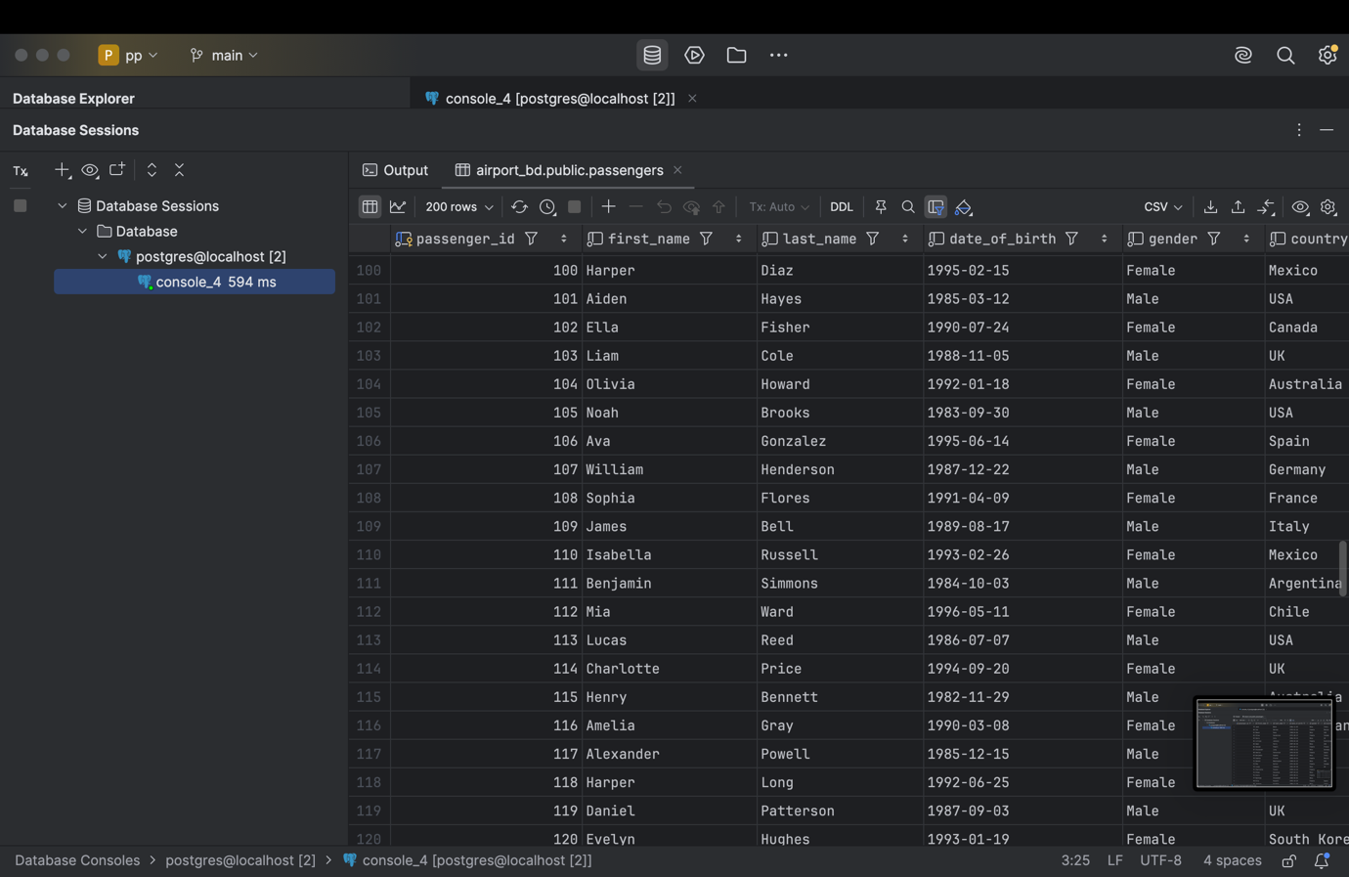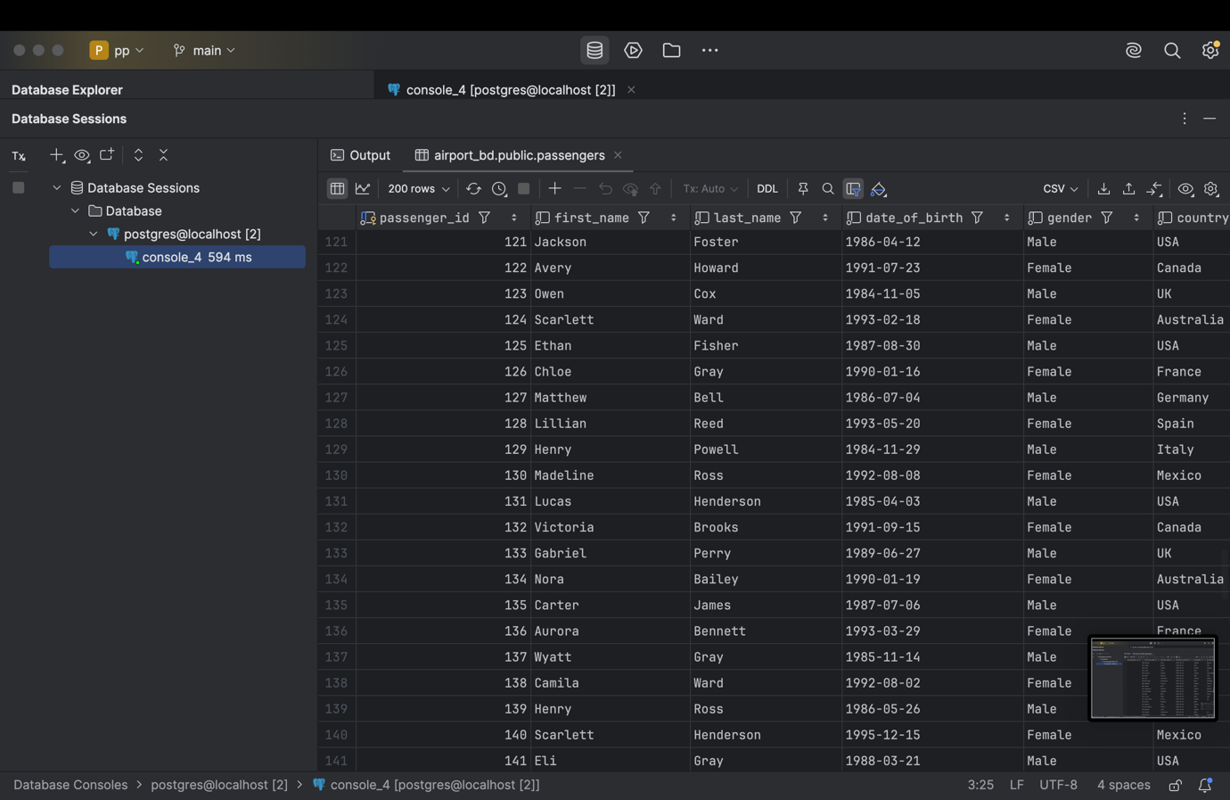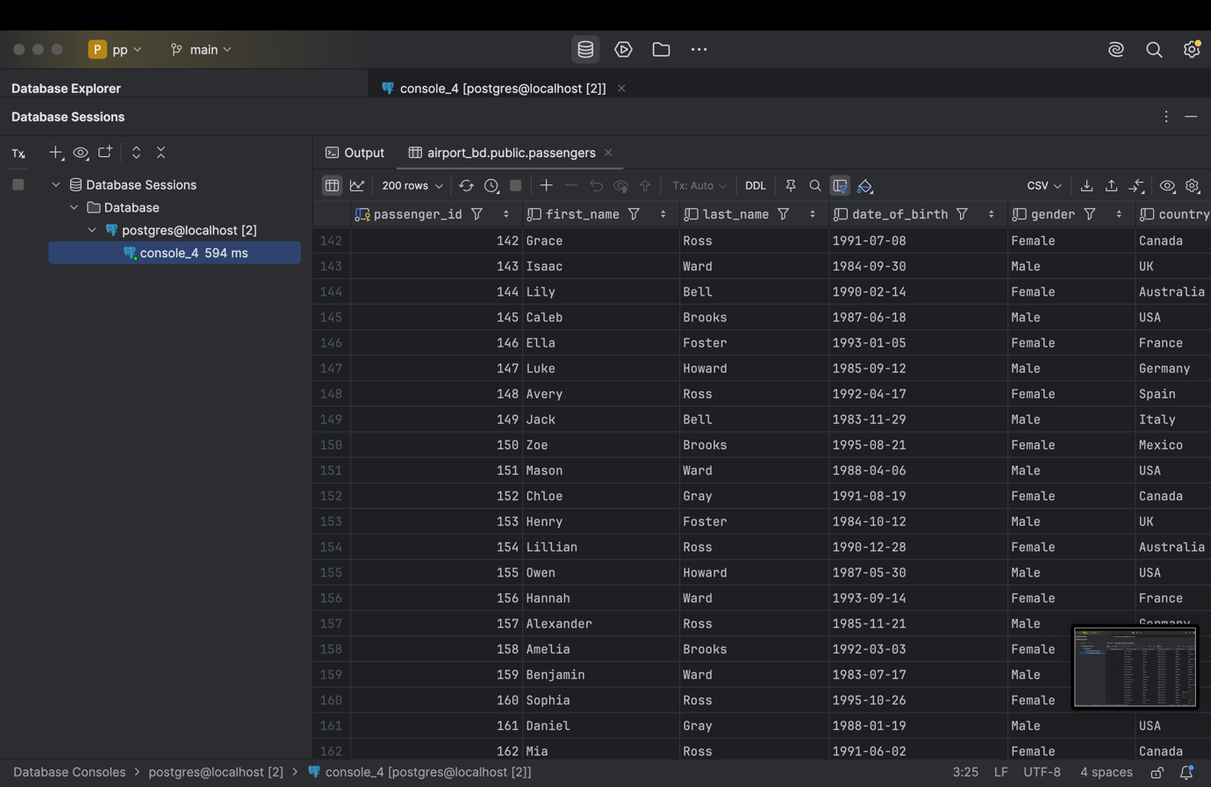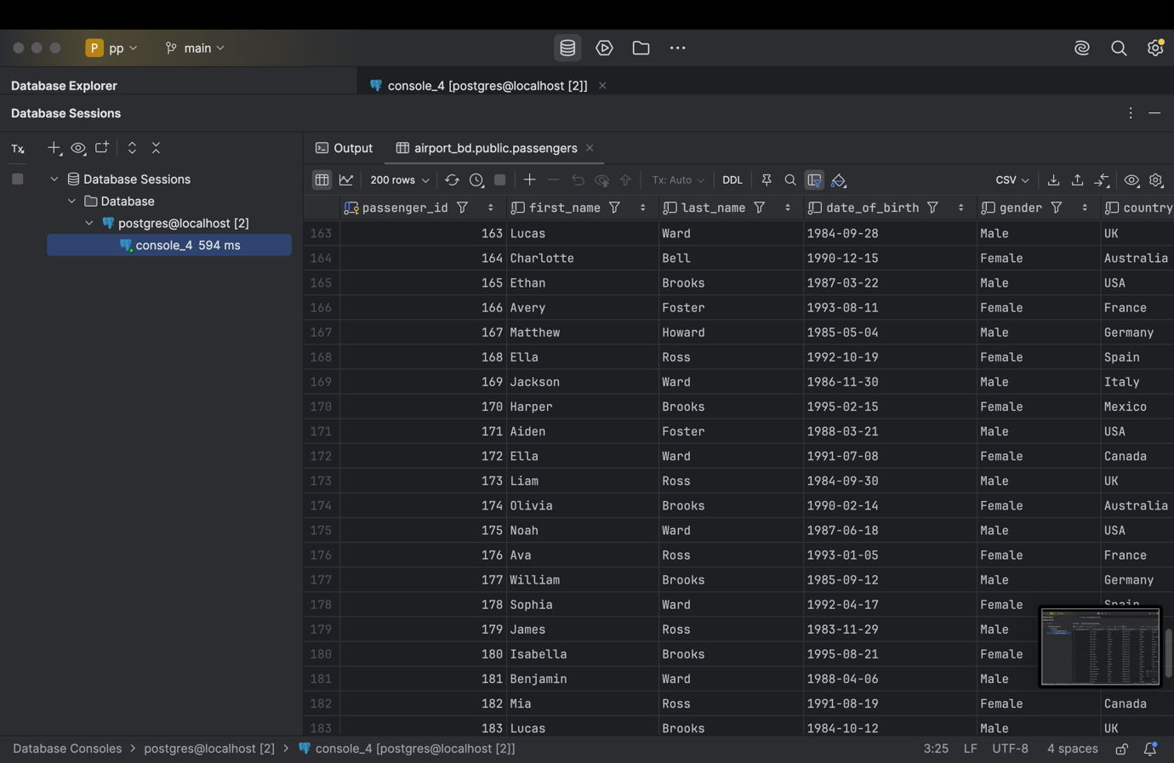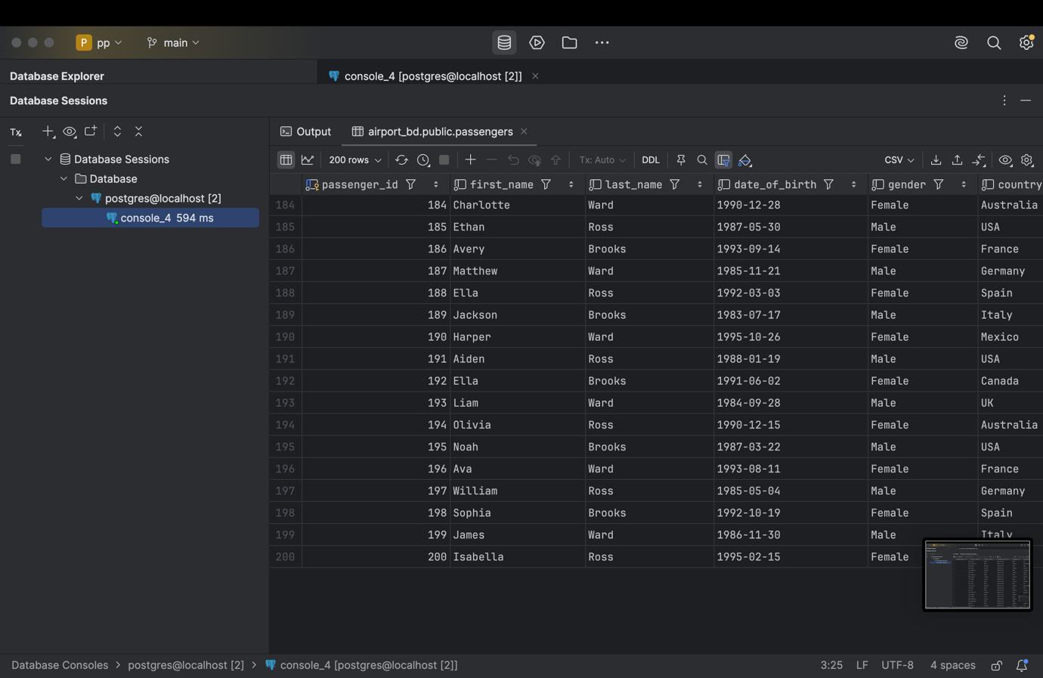

ALTER TABLE passengers ADD CONSTRAINT chk_passenger_min_age  
CHECK (*date_part*('year', *age*(date_of_birth)) >= 10);  
SELECT *FROM passengers;

1. Add a CHECK constraint to accept values in booking price not more than 50000tg and less than 0tg.

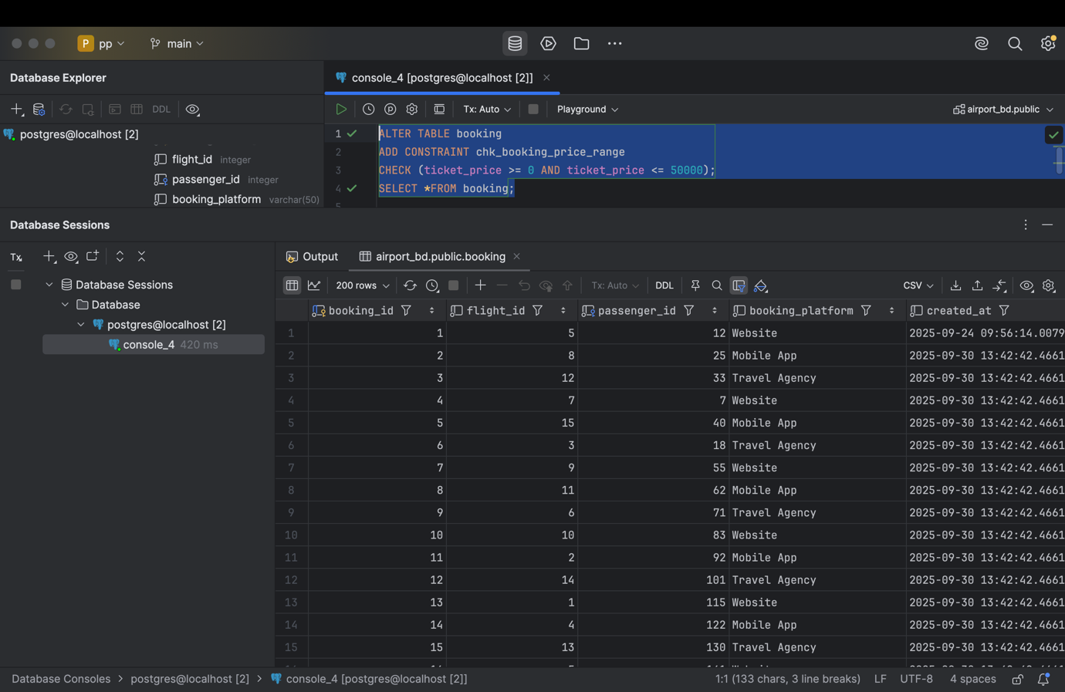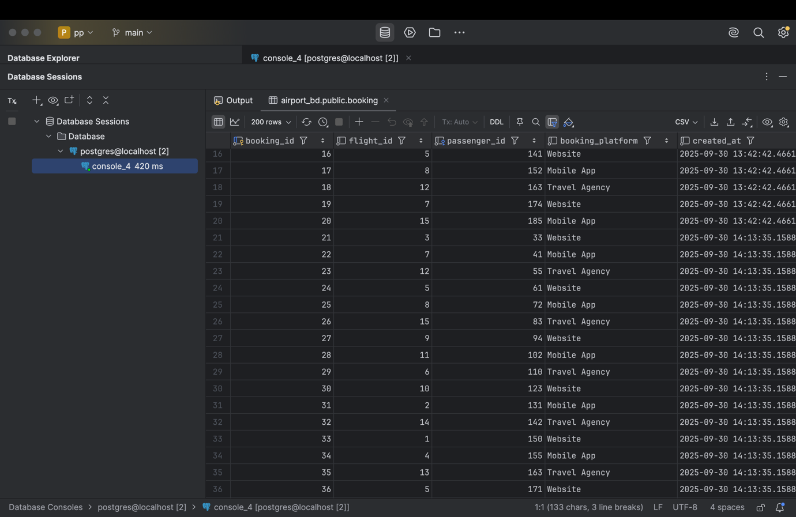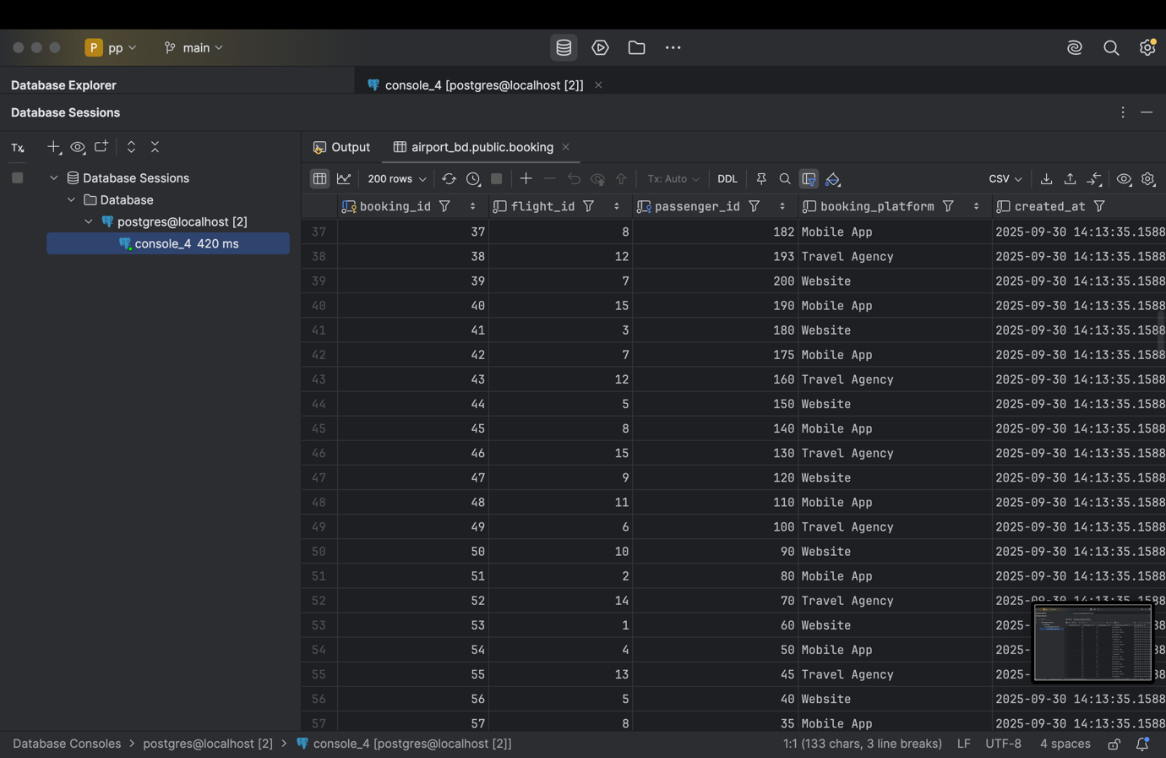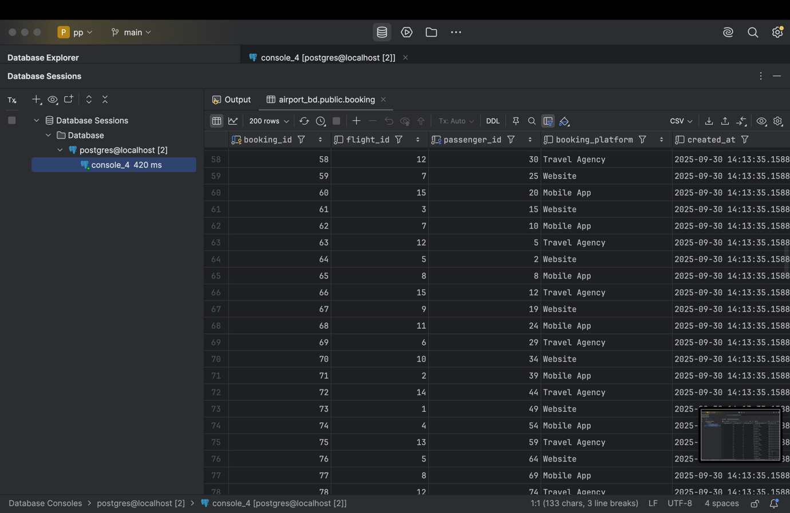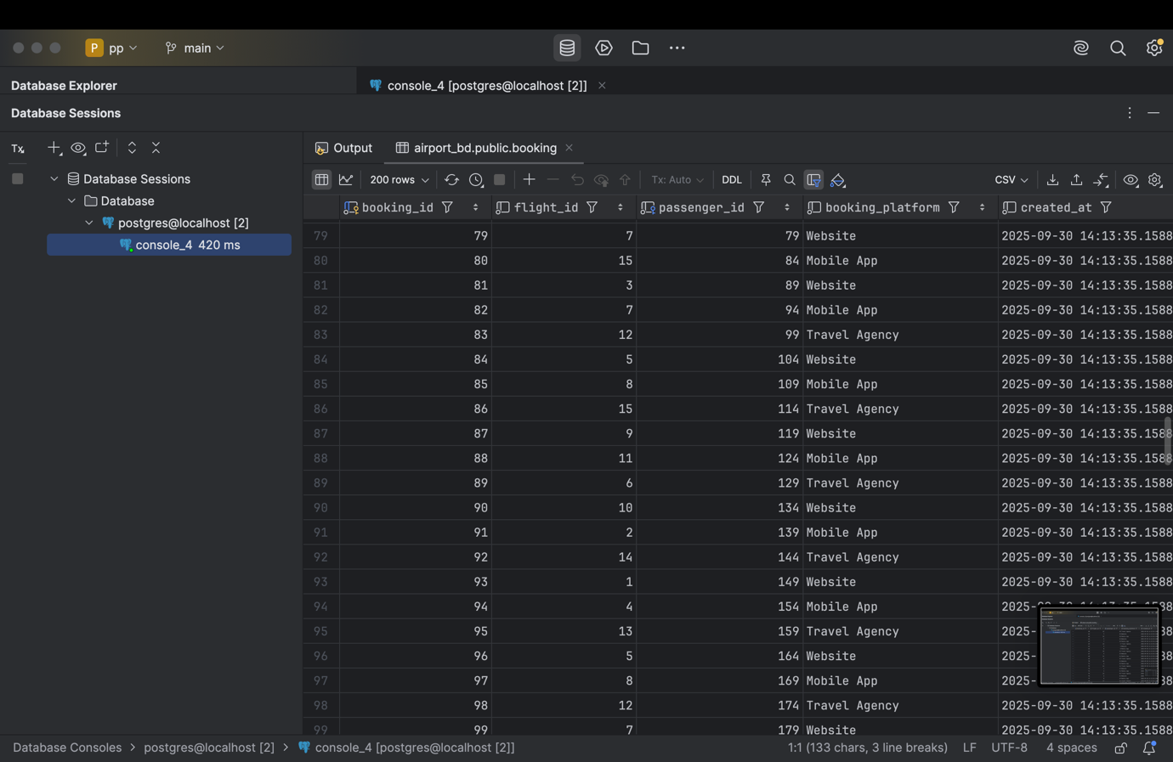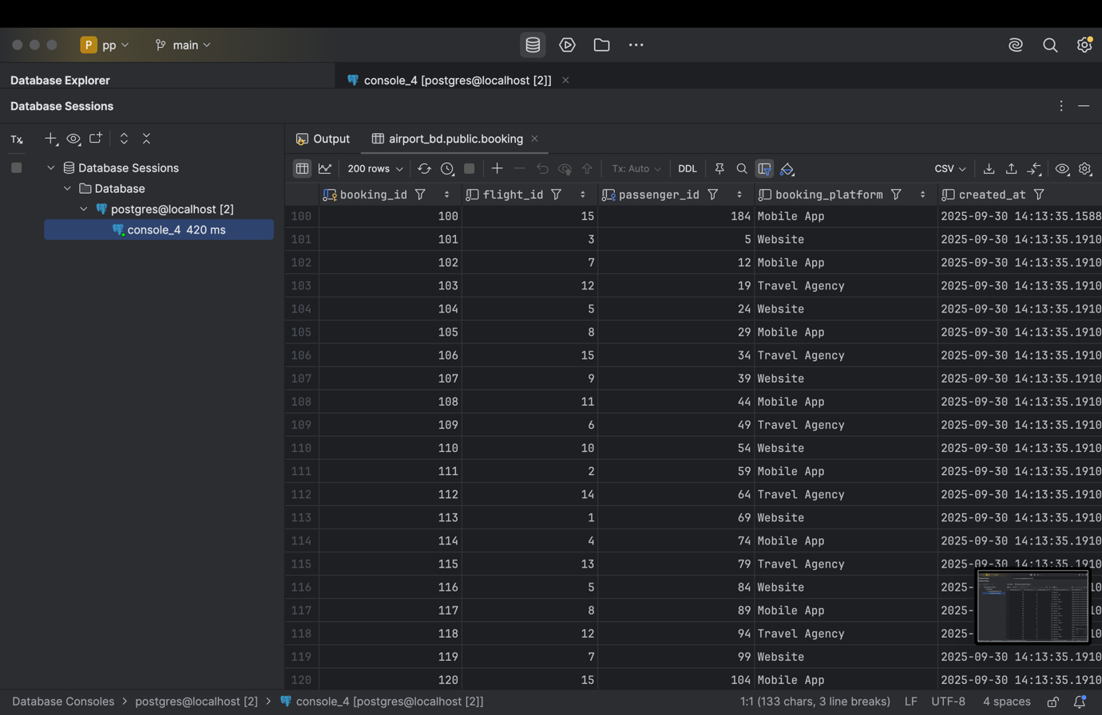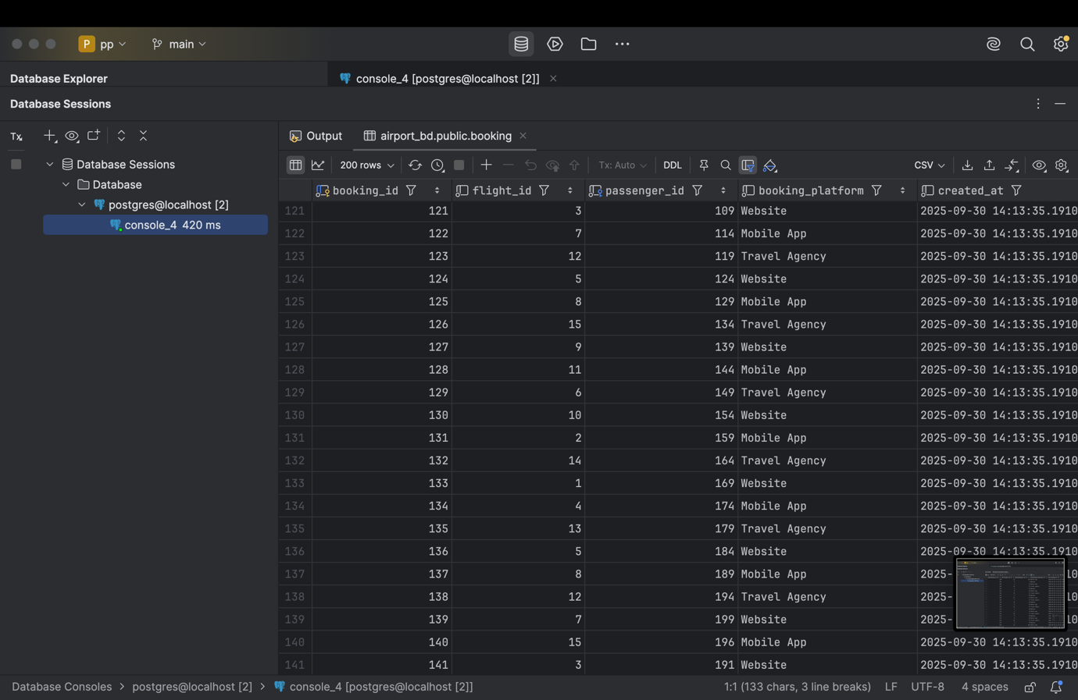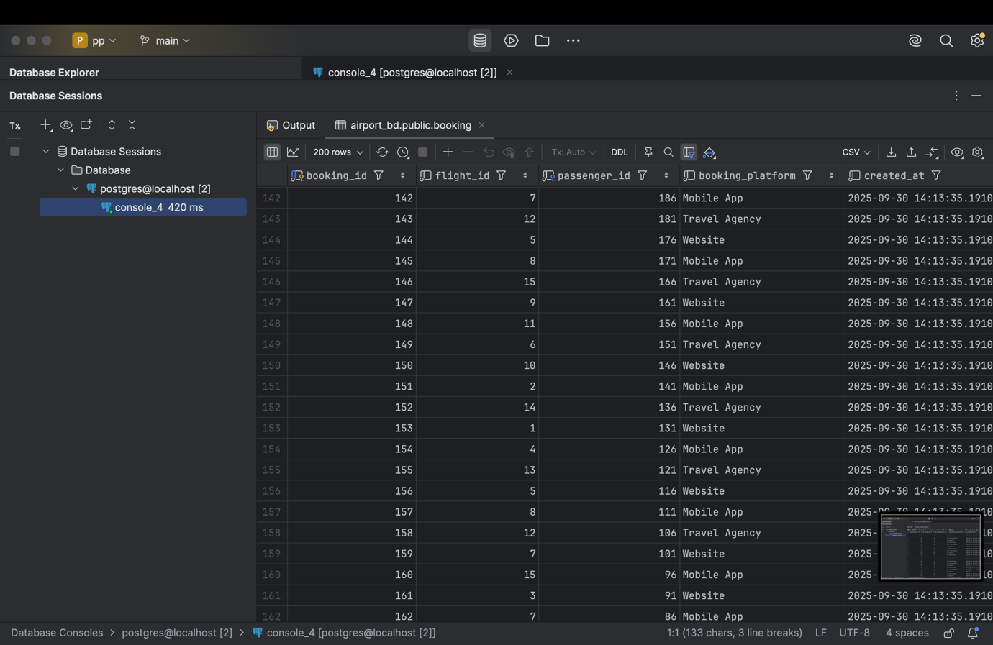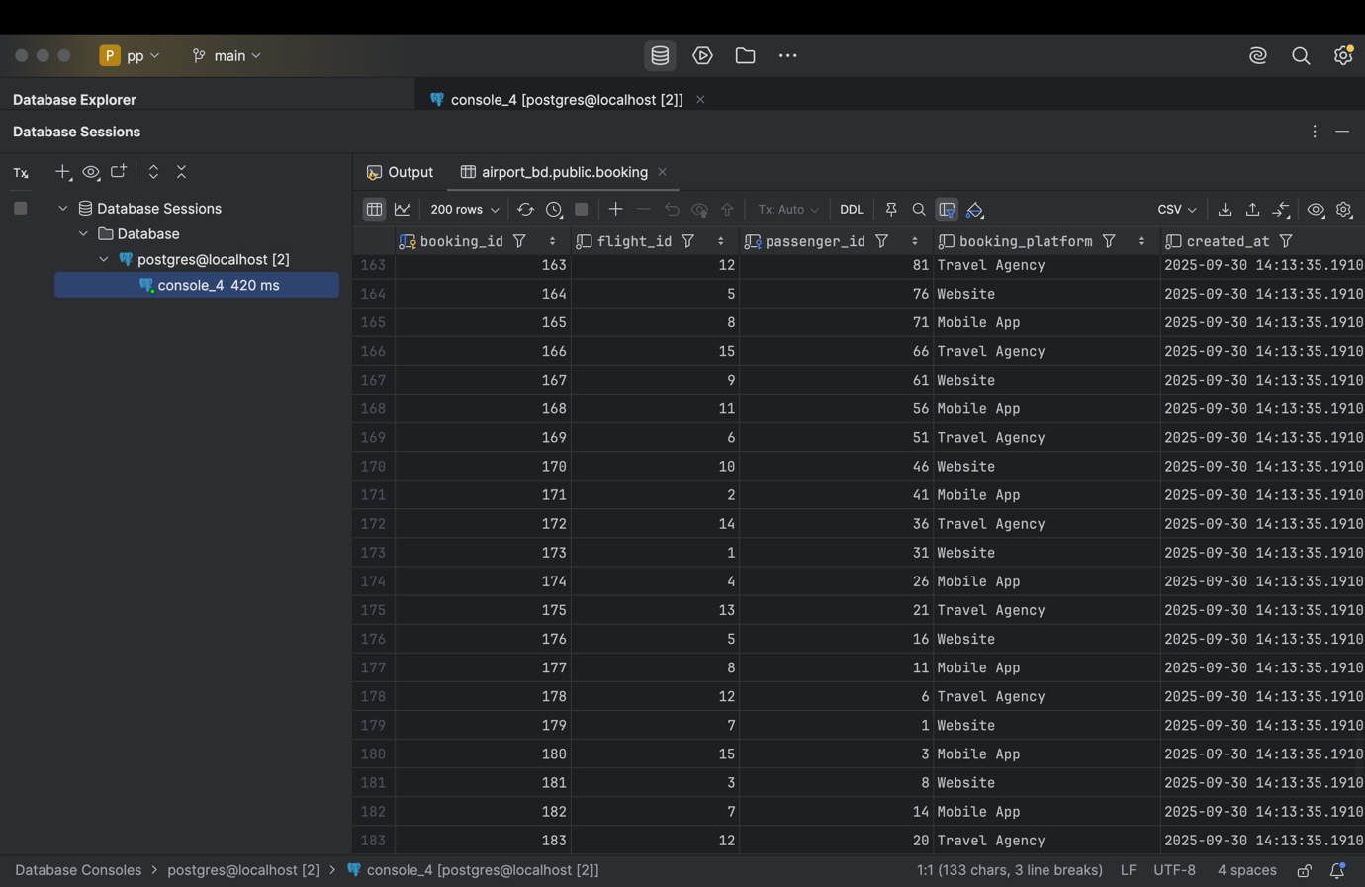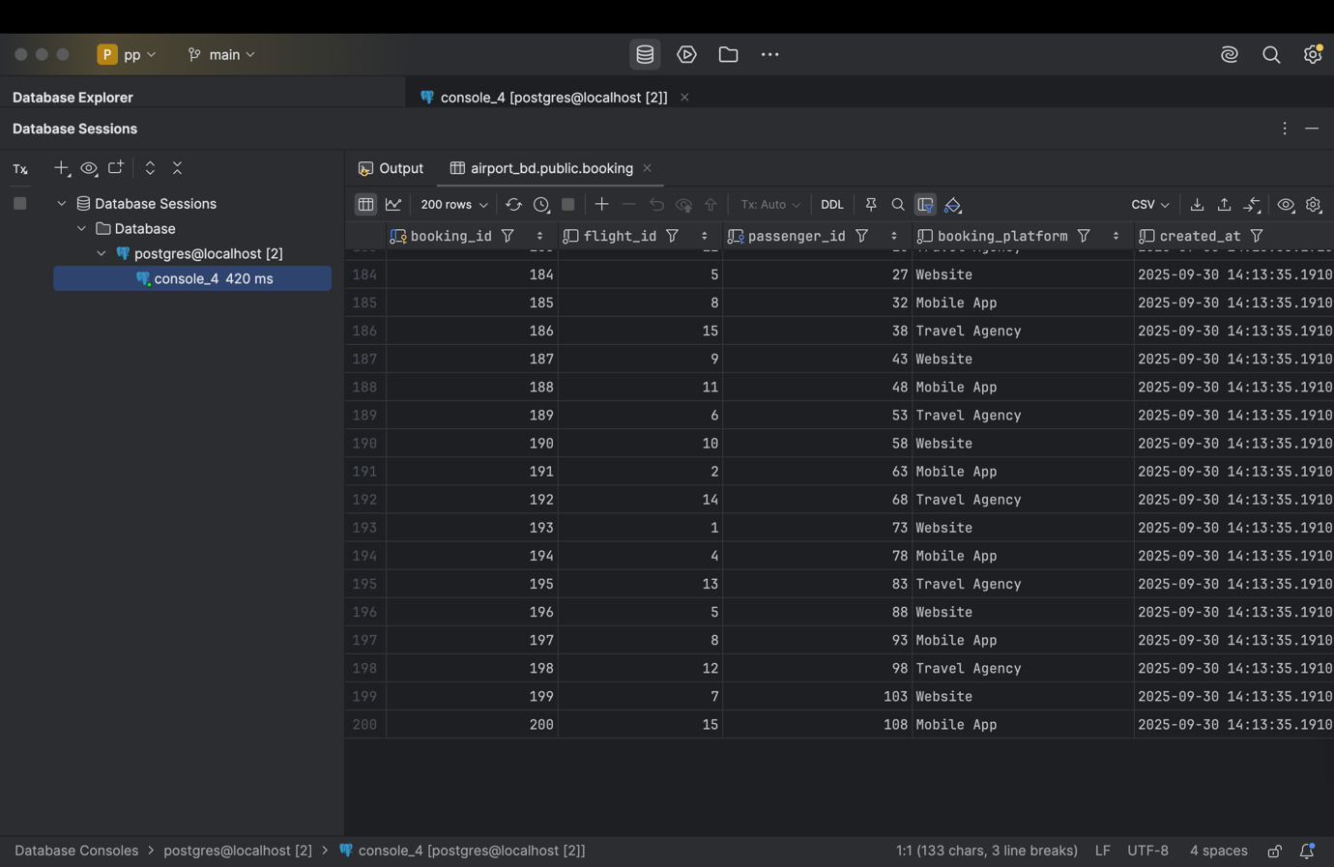

ALTER TABLE booking  
ADD CONSTRAINT chk_booking_price_range  
CHECK (ticket_price >= 0 AND ticket_price <= 50000);  
SELECT *FROM booking;

1. Add a CHECK constraint to accept the luggage weight between 1 and 23 kg.

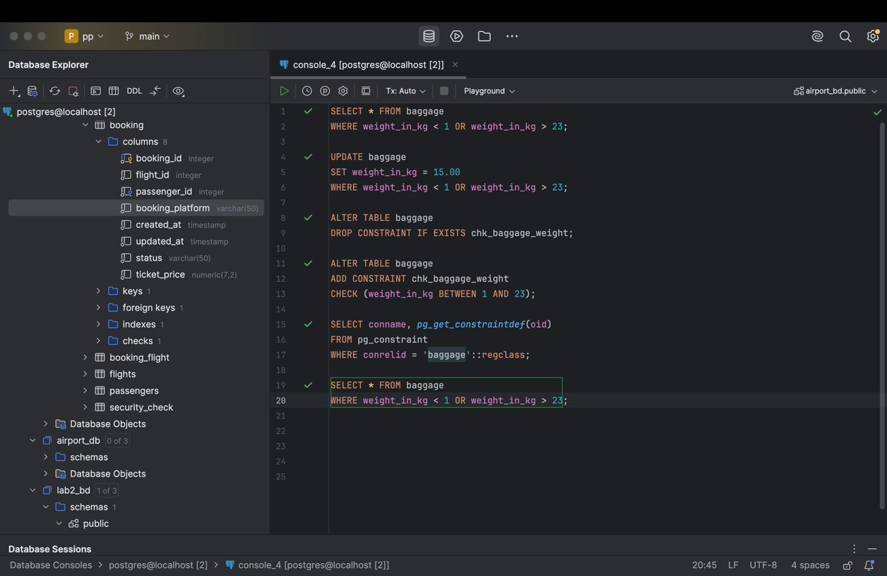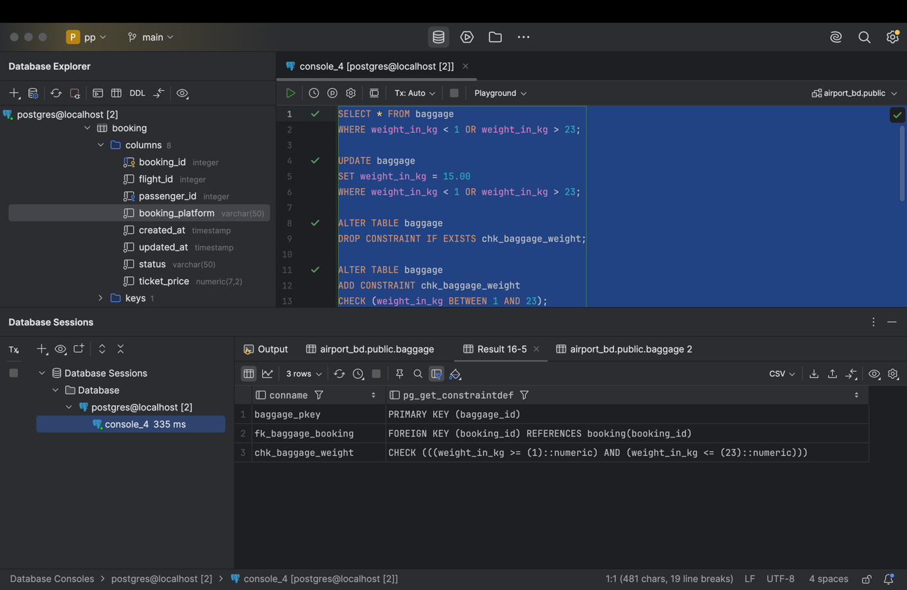

SELECT * FROM baggage  
WHERE weight_in_kg < 1 OR weight_in_kg > 23;  
  
UPDATE baggage  
SET weight_in_kg = 15.00  
WHERE weight_in_kg < 1 OR weight_in_kg > 23;  
  
ALTER TABLE baggage  
DROP CONSTRAINT IF EXISTS chk_baggage_weight;  
  
ALTER TABLE baggage  
ADD CONSTRAINT chk_baggage_weight  
CHECK (weight_in_kg BETWEEN 1 AND 23);  
  
SELECT conname, *pg_get_constraintdef*(oid)  
FROM pg_constraint  
WHERE conrelid = 'baggage'::regclass;  
  
SELECT * FROM baggage  
WHERE weight_in_kg < 1 OR weight_in_kg > 23;

1. Add a CHECK constraint to ensure that all values in airport_name must have at least 10 characters.

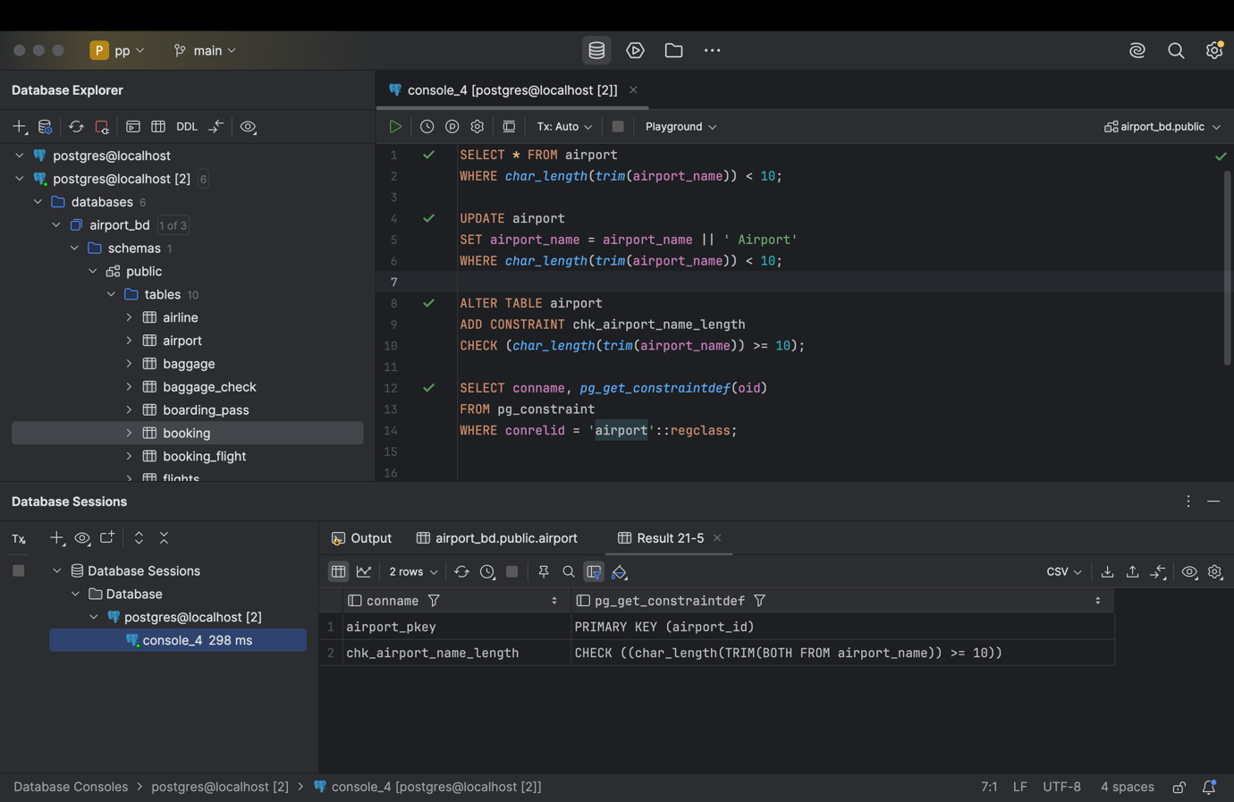

SELECT * FROM airport  
WHERE *char_length*(*trim*(airport_name)) < 10;  
  
UPDATE airport  
SET airport_name = airport_name || ' Airport'  
WHERE *char_length*(*trim*(airport_name)) < 10;  
  
ALTER TABLE airport  
ADD CONSTRAINT chk_airport_name_length  
CHECK (*char_length*(*trim*(airport_name)) >= 10);  
  
SELECT conname, *pg_get_constraintdef*(oid)  
FROM pg_constraint  
WHERE conrelid = 'airport'::regclass;

1. Add UNIQUE constraint to some columns in each table in database.

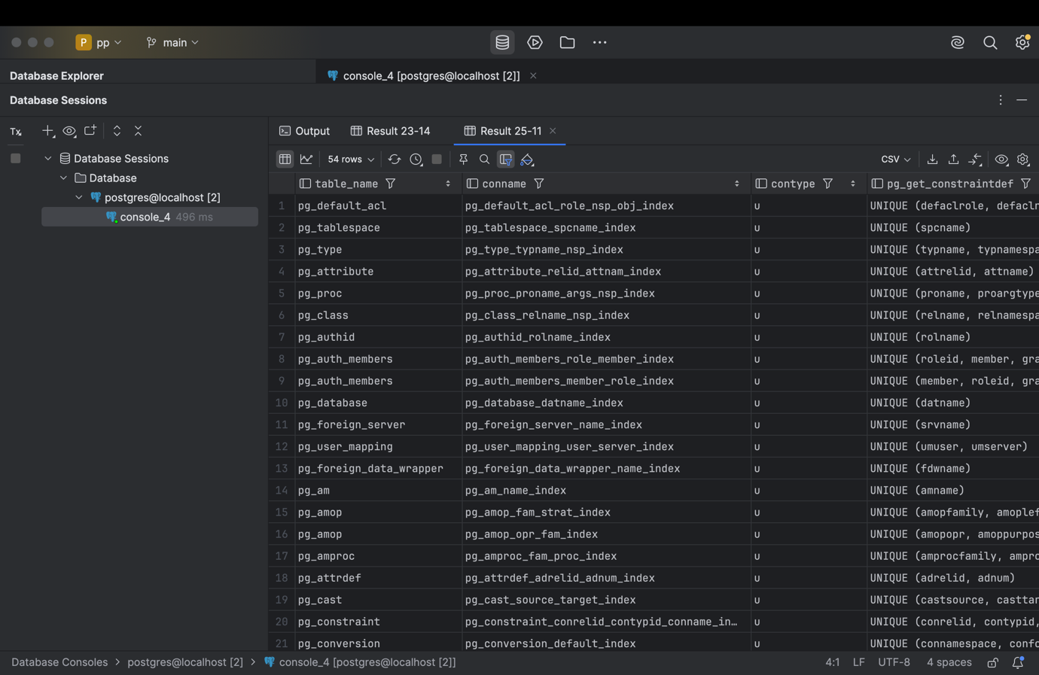

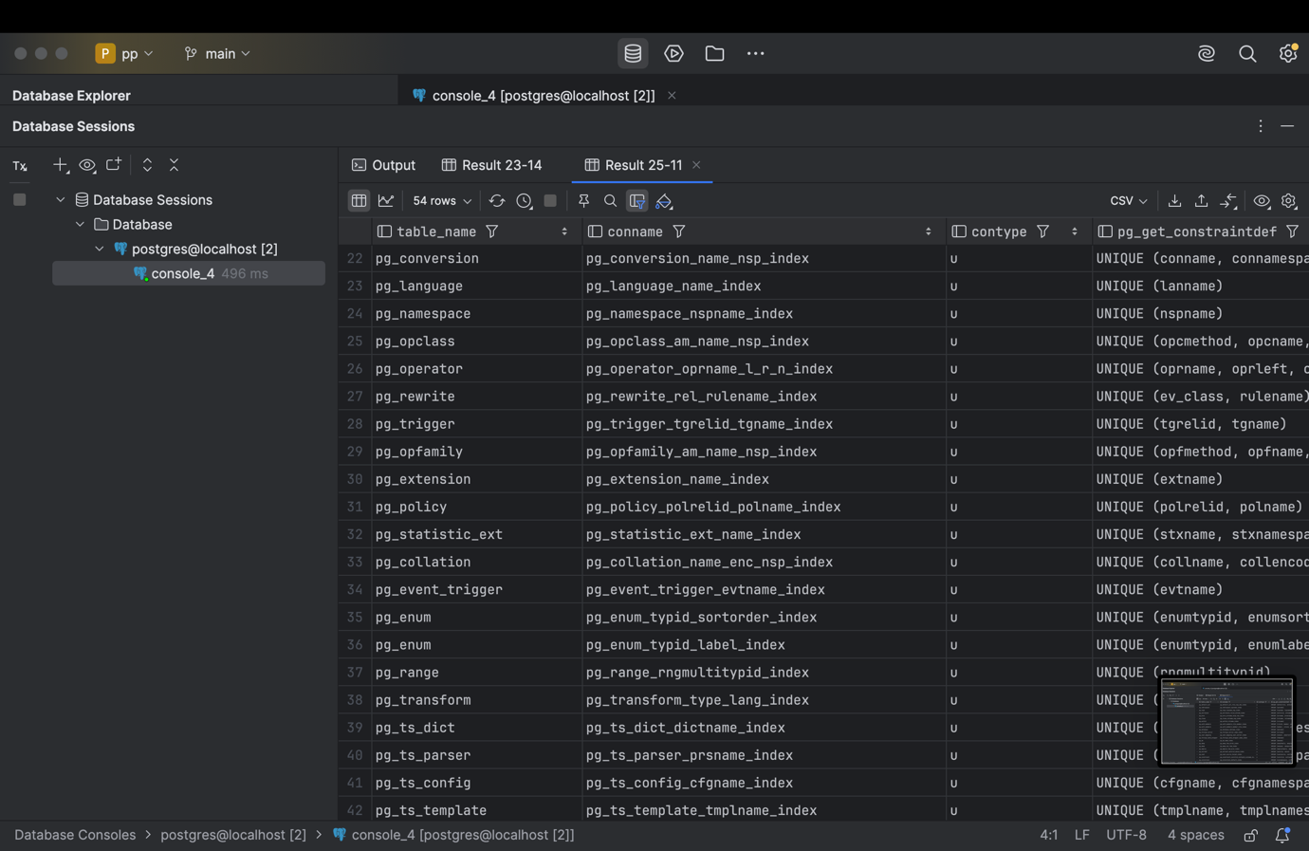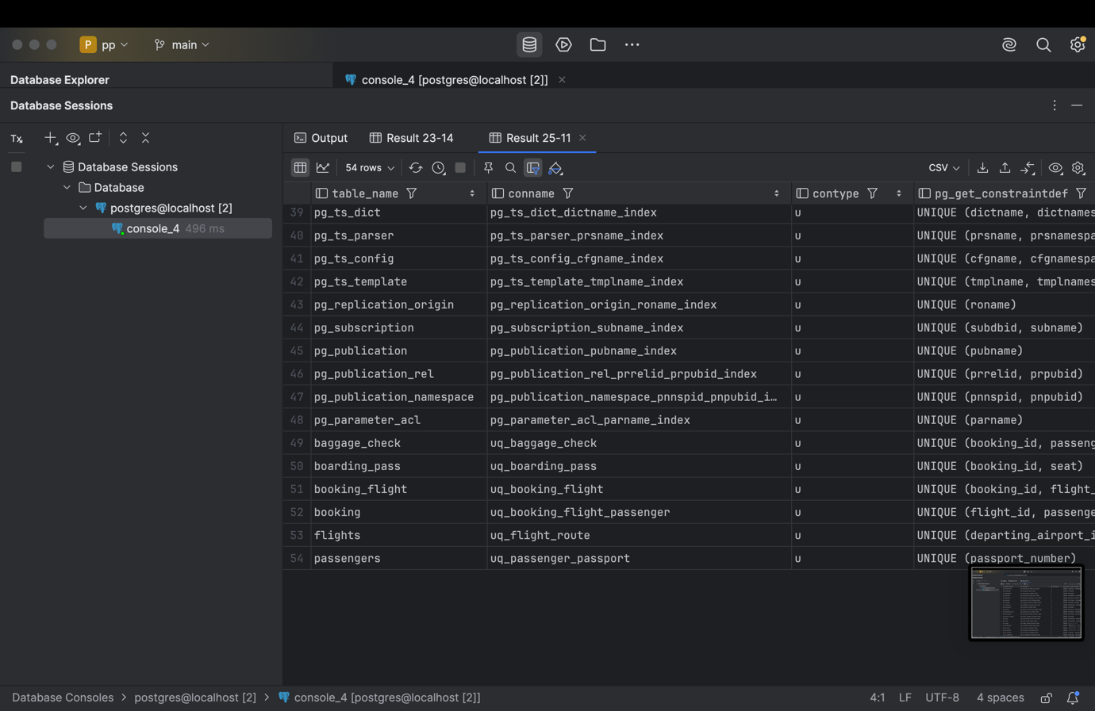

ALTER TABLE airline  
ADD CONSTRAINT uq_airline_code UNIQUE (airline_code);  
  
ALTER TABLE airport  
ADD CONSTRAINT uq_airport_name UNIQUE (airport_name);  
  
ALTER TABLE baggage  
ADD CONSTRAINT uq_baggage_booking UNIQUE (booking_id);  
  
ALTER TABLE baggage_check  
ADD CONSTRAINT uq_baggage_check UNIQUE (booking_id, passenger_id);  
  
ALTER TABLE boarding_pass  
ADD CONSTRAINT uq_boarding_pass UNIQUE (booking_id, seat);  
  
ALTER TABLE booking_flight  
ADD CONSTRAINT uq_booking_flight UNIQUE (booking_id, flight_id);  
  
ALTER TABLE booking  
ADD CONSTRAINT uq_booking_flight_passenger UNIQUE (flight_id, passenger_id);  
  
ALTER TABLE flights  
ADD CONSTRAINT uq_flight_route UNIQUE (departing_airport_id, arriving_airport_id, act_departure_time);  
  
ALTER TABLE passengers  
ADD CONSTRAINT uq_passenger_passport UNIQUE (passport_number);  
  
ALTER TABLE security_check  
ADD CONSTRAINT uq_security_check UNIQUE (passenger_id);  
  
SELECT conrelid::regclass AS table_name, conname, contype, *pg_get_constraintdef*(oid)  
FROM pg_constraint  
WHERE contype = 'u'  
ORDER BY table_name;

1. Add a CHECK constraint to ensure that male passengers must be at least 18 years old and female passengers must be 19 years old.

ALTER TABLE passengers  
ADD CONSTRAINT chk_gender_age  
CHECK (  
 (gender IN ('M', 'Male') AND *date_part*('year', *age*(date_of_birth)) >= 18)  
 OR (gender IN ('F', 'Female') AND *date_part*('year', *age*(date_of_birth)) >= 19)  
);  
SELECT conname, *pg_get_constraintdef*(oid)  
FROM pg_constraint  
WHERE conrelid = 'passengers'::regclass;

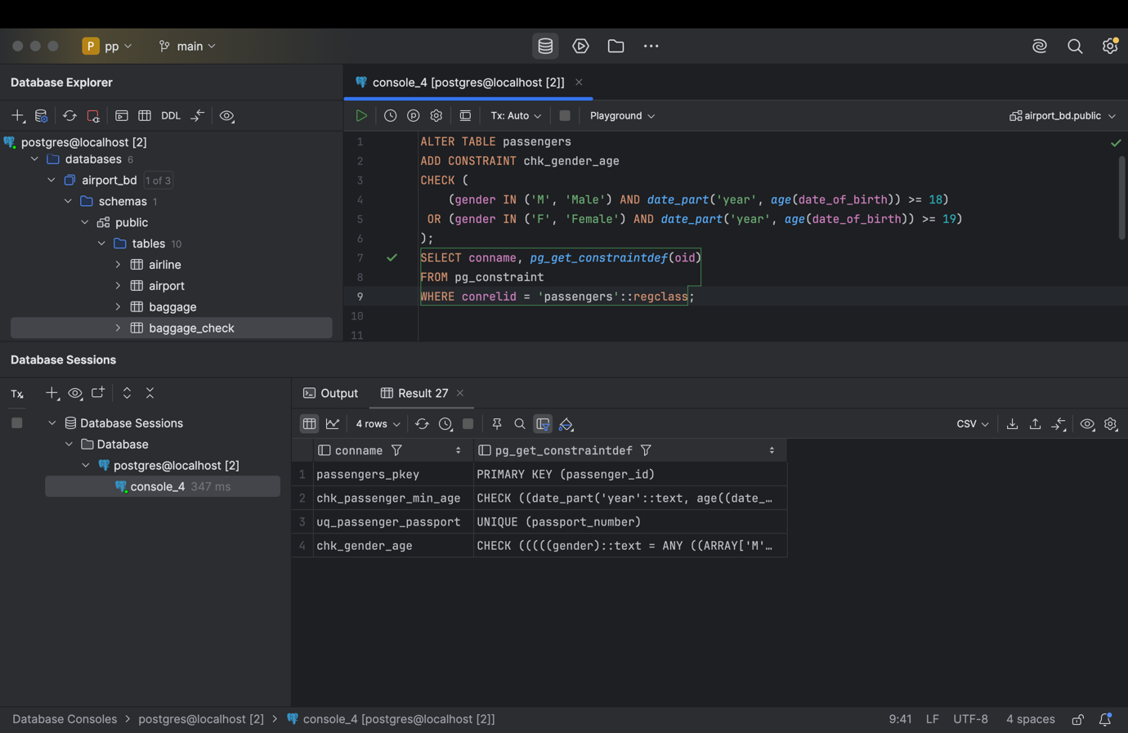

1. Add a CHECK constraint to add rule as follow (use column country_of_citizenship):

* Passengers from Kazakhstan must be at least 18 years old.
* Passengers from France must be at least 17 years old.
* Passengers from other countries must be at least 19 years old.

ALTER TABLE passengers  
ADD CONSTRAINT chk_country_age  
CHECK (  
 (country_of_citizenship = 'Kazakhstan' AND *date_part*('year', *age*(date_of_birth)) >= 18)  
 OR (country_of_citizenship = 'France' AND *date_part*('year', *age*(date_of_birth)) >= 17)  
 OR (country_of_citizenship NOT IN ('Kazakhstan', 'France')  
 AND *date_part*('year', *age*(date_of_birth)) >= 19)  
);  
SELECT conname, *pg_get_constraintdef*(oid)  
FROM pg_constraint  
WHERE conrelid = 'passengers'::regclass;

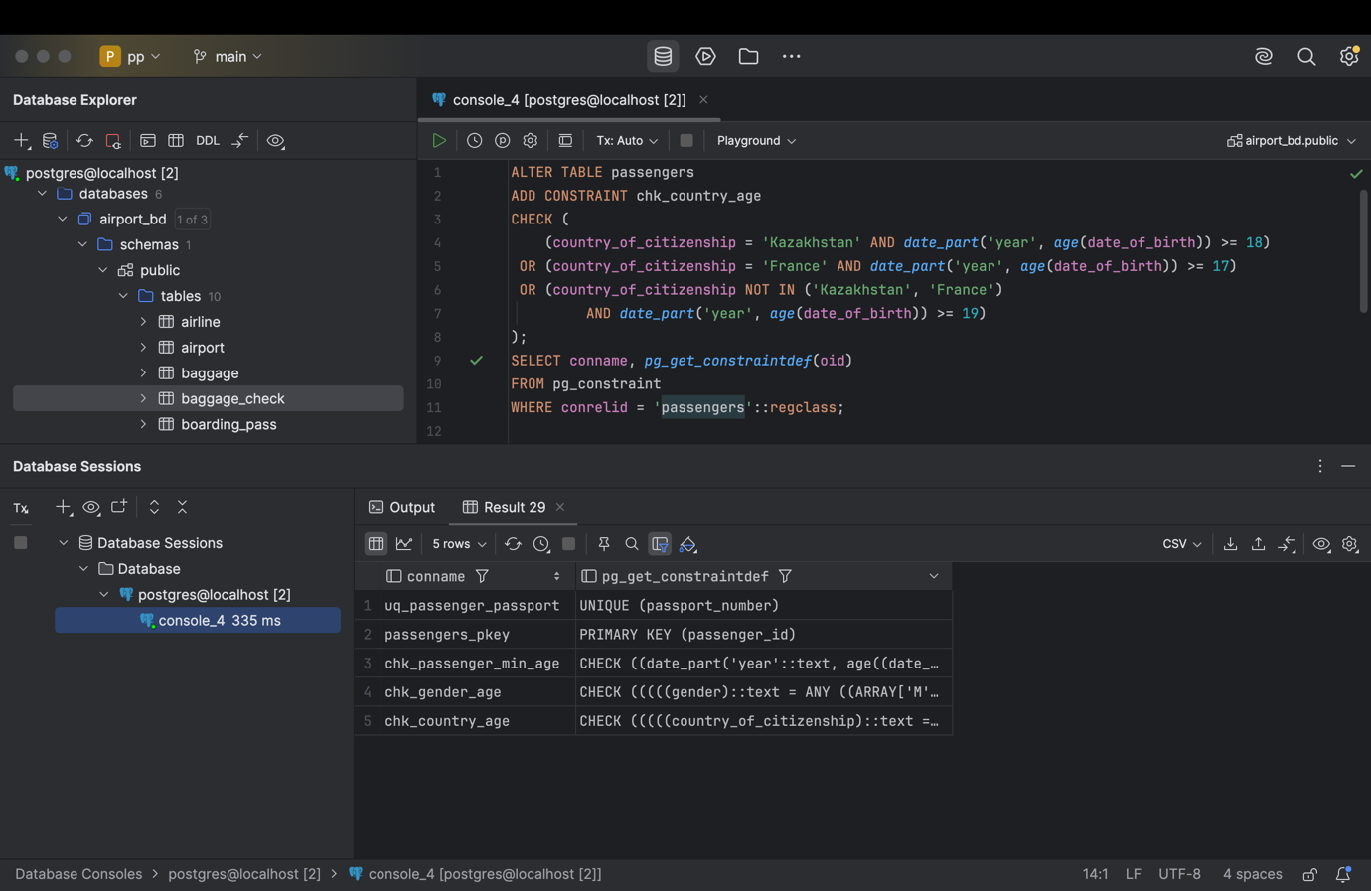

1. Add a ticket_discount column to table booking and a CHECK constraint to apply some discount based on ticket price and created time:

* the constraint applies a 5% discount for tickets created after 2024-01-01,

and 10% discount for tickets created before 2024-01-01.

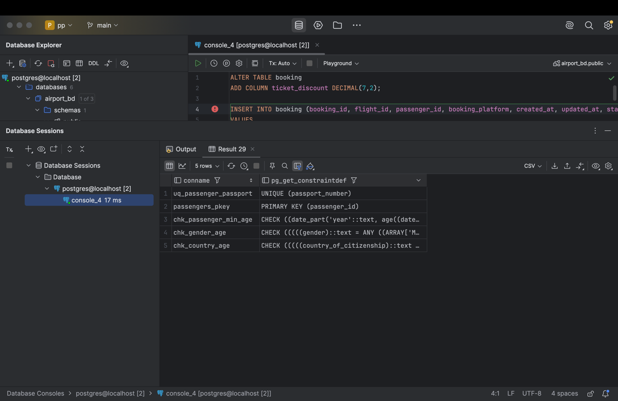

ALTER TABLE booking  
ADD COLUMN ticket_discount DECIMAL(7,2);  
  
INSERT INTO booking (booking_id, flight_id, passenger_id, booking_platform, created_at, updated_at, status, ticket_price, ticket_discount)  
VALUES  
(202, 101, 202, 'web', '2025-05-10', *NOW*(), 'confirmed', 40000, 2000),  
(203, 102, 203, 'mobile', '2023-12-15', *NOW*(), 'confirmed', 30000, 3000);  
  
ALTER TABLE booking  
ADD CONSTRAINT chk_ticket_discount_date  
CHECK (  
 (created_at > '2024-01-01' AND ticket_discount = *ROUND*(ticket_price * 0.05, 2))  
 OR (created_at <= '2024-01-01' AND ticket_discount = *ROUND*(ticket_price * 0.10, 2))  
);  
  
SELECT conname, *pg_get_constraintdef*(oid)  
FROM pg_constraint  
WHERE conrelid = 'booking'::regclass;